Step by Step Implementation

Creating an Android App to open Google Homepage Using Implicit Intent

**Step 1: Create a New Project in Android Studio.**

Click on Empty View Activity from the menu.

[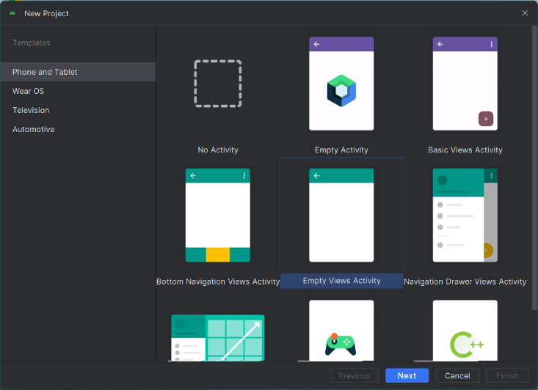](https://blogger.googleusercontent.com/img/a/AVvXsEi6m0RkiRC2wUbcAdVwwo0QhxIhD3-6u7CfK8XrZBOkLG25k0ckqQDDdX4J-kiTqMiqraJFwgPkxvJ6QtO2XyOWVbUqbHBW8LpbHmMWzcWnrqc7VZdSpeUjGSAZCecIXAitviD6khayQl3uSi0Qi-SZLfJcs-q5sEE4x-6lbDjQu3osGDS2JU4-K_dWQRrA)

Type in the name of your application. Here we have named our app "GoogleMaps".

Select your preferred language for coding. It can either be Java or Kotlin.

[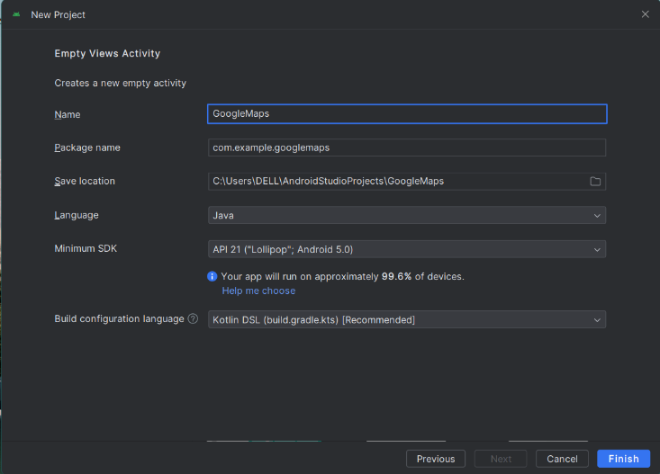](https://blogger.googleusercontent.com/img/a/AVvXsEjXXlz0t4sZJEmTaKk37Xni1mSQCXvJ7f-UPfUEq7WjAb63S78MByMTRo_jf4kG-pb5RuoyzFyyFmFDw0OpCloQopTsarKfQJCXj-nallYV8Ls02-jC0HEzXlIPbaCjJ7m5ysYgO7CxoJMnaGQ6Vcp5CzeWJ7M4wtmDrv3Wjr0i6FZSLTy9tKU97pus2FGZ)

**Step 2: Go to Google.com and type "cloud cloud console". Open the first link which appears.**

Sign in to the cloud using your email ID if not already done.

**Step 3: Click on Create Project tab at the top of the page.**

[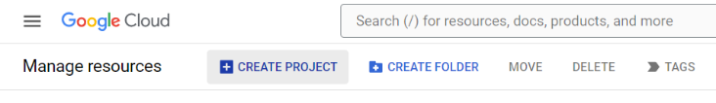](https://blogger.googleusercontent.com/img/a/AVvXsEi4UFxlU4k5GytODlLQamRbEhJV-6HlwwEs1Yw4vNItu09nkpLI124t6Jf6RlPBvqHYpBrl5O79pq2oesA9hn4Vu0diweQgicdRgf2Um5VOPcBAd5SsFVkhMTwSlo8oc2wdyV10B6BLitS2zH3XaZYV6SH2z7mIcqgTyaCHPrEsYHbT1XeENlx6SQyaDWnv)

Give your project a name, then press Create.

[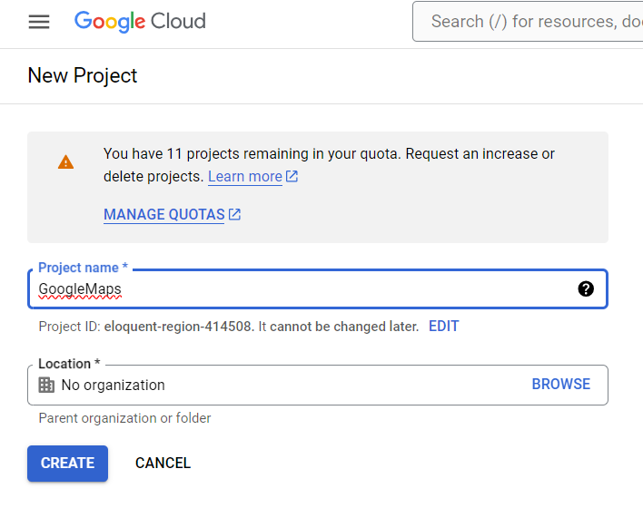](https://blogger.googleusercontent.com/img/a/AVvXsEg6oZRbdPh7u2vouijiy04H_kPk15iukagBqxGSr6xiYFDHd9Y1tGT8xhunslvIC0Tr_QfsL333V6CBi-cDKKAtAO_LX0YKQG6gmC2Ml_3LPo_od0g1HiLv-rVhfxVL3n2QUKNaGQqtTQ84CQp_xErDIIts7H-A_NvWKepvaf3AjWwQx2boCVbC_mvpgntk)

**Step 4: Open the Navigation menu, present on the top left corner of the page.**

[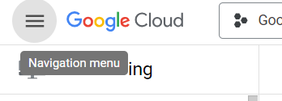](https://blogger.googleusercontent.com/img/a/AVvXsEh1IeXYxdXDxacX0rHNLPiS-WgjzCGxjdnJEillgvqRobkhAFPXtotERlPJiRX9kpirY_uuGISHMYrz3DLej2MxXuoVKJJiLQj5LCIoP1oSl8O0jrfrL3mhFEb-J9mmYy2REHab-_THeuQXrvtHEDxVhoJ6WFtfUvFBK6il4GBImCMhSqtSXd50-ZFaJZT5)

**Step 5: Go to APIs & Services > Library**

[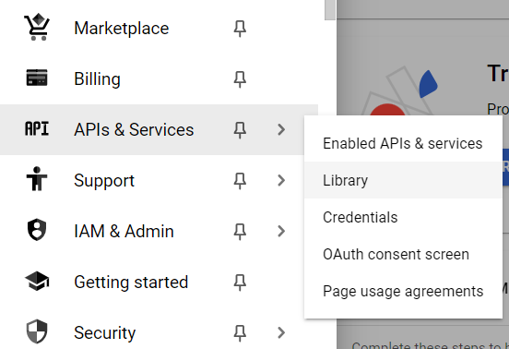](https://blogger.googleusercontent.com/img/a/AVvXsEhq4lBqeGtdCKqKwnr7CK71vutA8XJQ6tu8SaUi_O9ppzWklxEUudSyI408DHbdrune7XR8F4yyDL-Qb_e2Q_BjLt8m3DHPDOWCwRyGe0W3HMdRe5Uvb_jLzvh3kglHVTYDvY7dSK_6TZo8RjcD5NjtS6VDvWSEMLxZ6Z0X5lQZuaGDQqPwHark7KvlPAjU)

**Step 6: Click on Maps SDK for Android from the given list.**

[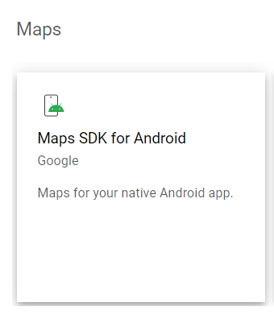](https://blogger.googleusercontent.com/img/a/AVvXsEgeQgzvKwN1eAt7BKIAv3Lo--KTbPSGEUwd3qMebGvQnR1A7X9Gu558587eC-4Yy1MsxbtvJ_N_CXJC1TP0dV5gdrw7vrJsFGS-zKEEsZpenqSvqlShE0mHZlNMBCY78NdJhPQlQwTYfd9YL3TkbrUCzOnQOv1TJaEA2YE7KLc2YJFN5gDPFC1sumQQV5eH)

**Step 7: Click on the Enable button to enable the Maps API.**

[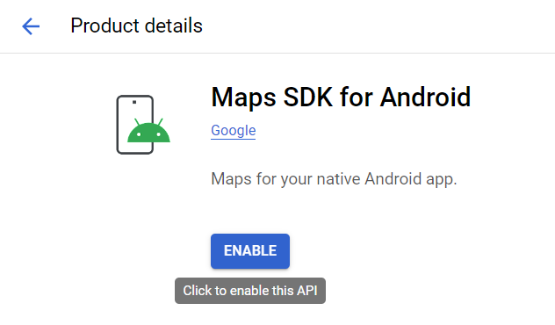](https://blogger.googleusercontent.com/img/a/AVvXsEgmkPuSxtRW52Km55uN7x0euyQbEvrNHlofVRWI0LxnY1Js29p1-NRZ4mpHXphDIFSy792cE_Z1323zaRJ8Vdb59G35Fxdji46ef_DQvqXBjXpNGItY3b8C6i73BlLXI8om-ng2geYLrhR46Vci9pwL6aEA69lfjcGrzZ85TJA4WF5NpN8okdWpA9oQtYON)

**Step 8: Open the Navigation Menu again and go to APIs & Services > Enabled APIs & services.**

[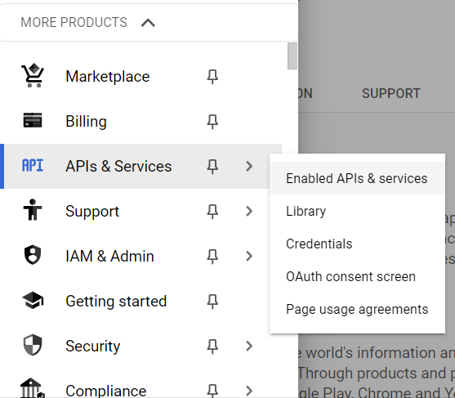](https://blogger.googleusercontent.com/img/a/AVvXsEhC0TjbdutKn_eAYyeNJQbKRLaM3tDnQZ9jeKoawpk-HSIfB8bPtFQm_aIbU4KW_2fKVsKIxo-o6RvgR_Tvp2OHeHioi213EPPYvZNJUZw-9Mw9wyFXCLpjh1a7ZSfL4XoNFmVJKkiWqgzevr2gHA02Klo-XUpeHjScRN6AGYx2C0aE4z5R8m5d7k7jdNac)

**Step 9: Click on the Credentials option from the menu on the left.**

[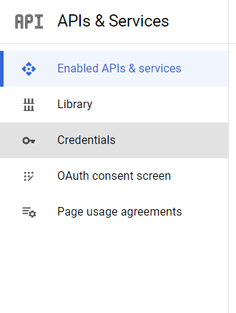](https://blogger.googleusercontent.com/img/a/AVvXsEgY-ULg07hQjAlxVOeWzx1hrIbs9TjOBhJoBFm1aaKNcn7BfM1my90ZAml5iCnnl3T5W4ammVbuDczGDuAQNXr_2hMN3n5mULD7c5WJnYu2aLEcYybkE6QHhh4GKD5ck-E5ti4RJLCYWERh4e_nBUGs6wAFSSoSnA7HePRi0M8eYiOP_3Ey7m0n2Hn0g1j0)

**Step 10: Press on Create Credentials > API Key to generate the API key.**

[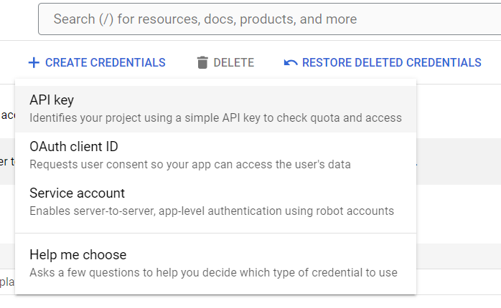](https://blogger.googleusercontent.com/img/a/AVvXsEgCp9p8sdbnNis5-6QOUuMytcTV1y0cb-1QFN0FX2BKjTERiWx5zYc9w8N4qDJ2z5Xpe-nZz93ip4V9ZO3iPtiF8StQsIWHxX4a_RvcvgriIQtZ27vQpNDHV3-pmJjZUe54zRqucLNZAwqBUnDwmeVflOUWQZaMHhdO-GlSP2cgDH7caoMwzzDtT32E40eI)

**Step 11: The API Key will then be generated, which can be used in our app development.**

[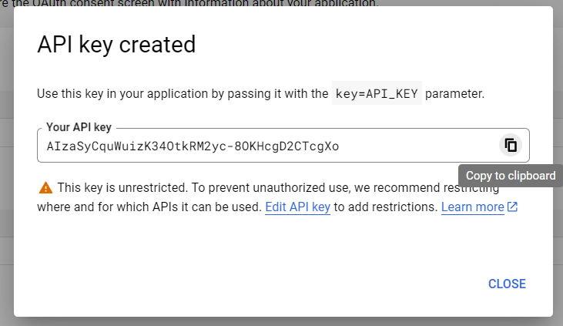](https://blogger.googleusercontent.com/img/a/AVvXsEieCegoeHESJPADBUJ1LVBFT-v4UBO9dJTo2pl8pDJAJVD6f6M-LDn9yO_UvIs6jbFtUfg4gldjplZDHXPy1OKfu1eKvSmuilYTngpX8DQeTWuQGg0dAxc89kohzoQIlHR23PEhL-xJQlSHqHidWST_nDKRM4Cp_olXjJB7mJolIbKWDFsFdK3yzZ7S9x9h)

Minimize the window for later use.

**Step 12: Open the project we created in the earlier steps, in Android Studio.**

Go to res > values > strings.xml

[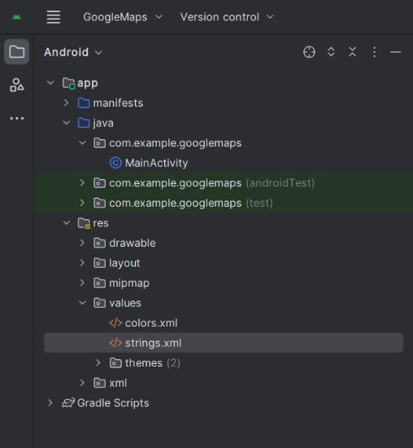](https://blogger.googleusercontent.com/img/a/AVvXsEjCIKZxo0DFjhNWHdnQsYpuPSDA4vcRIFeDfvftBYnDDpQIy4oEnn4KVm8OqqlzQix1kmRIpZ5ExQ8Y1q4zq0_Zy0xEpgK3jEHlCEMtxETFoifDFlh1_AcUvsJsF8s2ON-4IR8_TItQX8RiFYJCc6PlcMeL6aVKQ5_Fhd_IPkrvQW3vgblamC_bMkvIGpkO)

strings.xml:

<resources>  
<string name="app_name">GoogleMaps</string>  
  
<string name="my_map_api_key">YOUR_API_KEY</string>  
</resources>

**Step 13: Open the Google Cloud Console again and click on the API Key we created earlier.**

[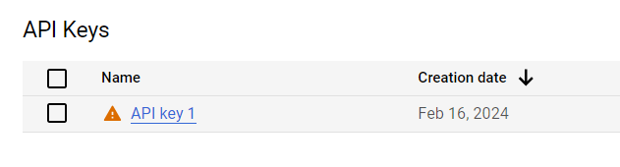](https://blogger.googleusercontent.com/img/a/AVvXsEhhFPq-h-FqN9YfyYlOkp9UkdVnPAUeHGu4gCO2d-bxKox1mm2eZ68qpt_mAZ9QOCVQTjio5CvFnYElqLs_3yCOTJciEQZcmffc8qyMpZUiZ3TyPX_6Tm1ca-RFIu3KWyrhF-P2KlQ3P-4m1tr4anysUpi81F4TNGeYeQ3aUNuOh6AMoHRT3vp0rHI7zeio)

Then copy the API key.

[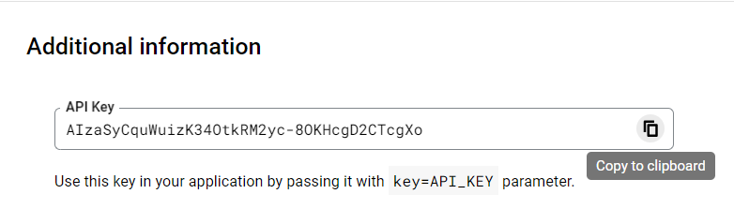](https://blogger.googleusercontent.com/img/a/AVvXsEgq_oGKhORMO8tRzoPqycsNoDy0hb1lZq81GcC55twqHABkhHjJj90NMGe6TDDq2wC9Au7OwHsgy-TYrKd2bvN6y0ABEdfx_0RLfIDRKf_MidQb2m0rRH_992-W-LStQ-O_eIU1uG_48NPB_tzCEltnLihREkh1D_eiZ1nCIcIX9tTYwQ4tID3DvuF-X_MB)

Paste the API key in the strings.xml file in place of  YOUR_API_KEY in the given line of code.

<string name="my_map_api_key">YOUR_API_KEY</string>

**Step 14: Visit the given link**

<https://developers.google.com/maps/documentation/android-sdk/start#maps_android_mapsactivity-java>

Scroll to the Module Gradle file section, and copy the highlighted code.

[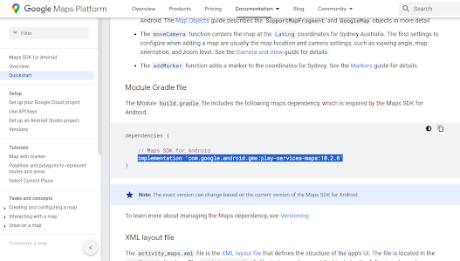](https://blogger.googleusercontent.com/img/a/AVvXsEjJ7j1ylKZRKJrpIqPujQ7OFLYCHJIMA1WOrhrw7UkMm1mkMS7u5krTGhfymIT2BFCwQBZCTgeYjfcvZkrNDHcOLTbUjykXkx2cv_y0CZQn--j34RSbocgAaa1az1e76SINhdQrv8HvLBB7-AKITmsb7_yzJSBqxSoY_8JL8QIHWVwuYl5AEpwWfxyr-408)

**Step 15: Open Android Studio, and paste the copied code in the build.gradle.kts (Module :app) file.**

[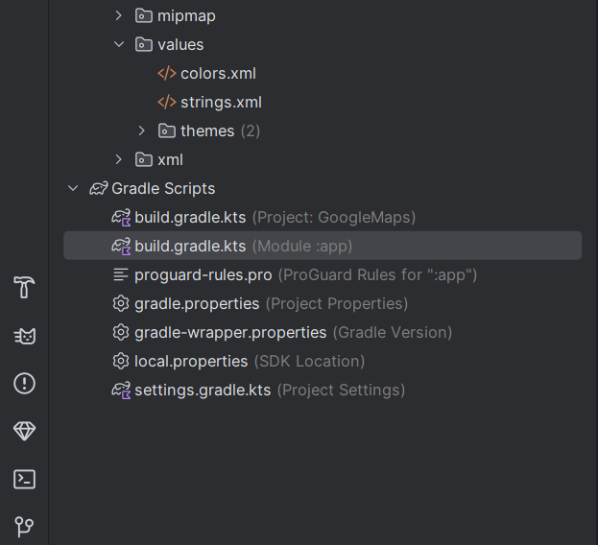](https://blogger.googleusercontent.com/img/a/AVvXsEg_7Dn56nipSPAzj04LKoAhGsZ3RaIOXAhXtQLYanfOYr87LGMaFTThTd1CT7kgWhOdYmZz3uqAz_1AGhi3_BnVFR4Rfu8IkJ2N1rfwLgzBN19xqXPjWHzrBRahtrKvGSGNCkgvxaj7cVmPtZBEBB5-PWli78mtZ3bbNmpadEvVxLzoNkz0O5Hv6hvNo7z3)

**build.gradle.kts:**

plugins {  
 id("com.android.application")  
}  
  
android {  
 namespace = "com.example.googlemaps"  
 compileSdk = 34  
  
 defaultConfig {  
 applicationId = "com.example.googlemaps"  
 minSdk = 21  
 targetSdk = 34  
 versionCode = 1  
 versionName = "1.0"  
  
 testInstrumentationRunner = "androidx.test.runner.AndroidJUnitRunner"  
 }  
  
 buildTypes {  
 release {  
 isMinifyEnabled = false  
 proguardFiles(getDefaultProguardFile("proguard-android-optimize.txt"), "proguard-rules.pro")  
 }  
 }  
 compileOptions {  
 sourceCompatibility = JavaVersion.VERSION_1_8  
 targetCompatibility = JavaVersion.VERSION_1_8  
 }  
}  
  
dependencies {  
  
 implementation("androidx.appcompat:appcompat:1.6.1")  
 implementation("com.google.android.material:material:1.11.0")  
 implementation("androidx.constraintlayout:constraintlayout:2.1.4")  
 testImplementation("junit:junit:4.13.2")  
 androidTestImplementation("androidx.test.ext:junit:1.1.5")  
 androidTestImplementation("androidx.test.espresso:espresso-core:3.5.1")  
 implementation ("com.google.android.gms:play-services-maps:18.2.0")  
}

Step 16: Go to app > manifests > AndroidManifest.xml

Type the following code in the AndroidManifest.xml file.

<meta-data  
 android:name="com.google.android.geo.API_KEY"  
 android:value="@string/my_map_api_key" />

**AndroidManifest.xml:**

<?xml version="1.0" encoding="utf-8"?>  
<manifest xmlns:android="http://schemas.android.com/apk/res/android"  
 xmlns:tools="http://schemas.android.com/tools">  
  
 <application  
 android:allowBackup="true"  
 android:dataExtractionRules="@xml/data_extraction_rules"  
 android:fullBackupContent="@xml/backup_rules"  
 android:icon="@mipmap/ic_launcher"  
 android:label="@string/app_name"  
 android:roundIcon="@mipmap/ic_launcher_round"  
 android:supportsRtl="true"  
 android:theme="@style/Theme.GoogleMaps"  
 tools:targetApi="31">  
 <activity  
 android:name=".MainActivity"  
 android:exported="true">  
 <intent-filter>  
 <action android:name="android.intent.action.MAIN" />  
  
 <category android:name="android.intent.category.LAUNCHER" />  
 </intent-filter>  
 </activity>  
  
 <meta-data  
 android:name="com.google.android.geo.API_KEY"  
 android:value="@string/my_map_api_key" />  
  
 </application>  
  
</manifest>

**Step 17: Copy the following code from the link given in Step 14.**

[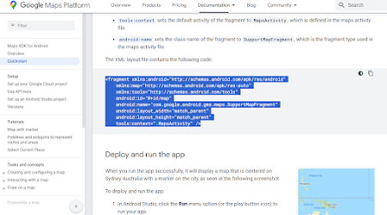](https://blogger.googleusercontent.com/img/a/AVvXsEipZAs1FuclWsRWEWanZmNOKUfA_4Vs0OqHSGJO8PLHUsG62YHoCGx0BVmzf0iNldv0IZ7oSeQcPmNowQVw--18YFEh8jQ2leg9EF3xB7h5FqzjNAy6OpfWyrW9AoCSK9m_2hLP84zIsoS3K8WSzoXzfGDKjm0HicXFnpmPK-BG7EbtiTBWIA-ocdoAtV1y)

Paste the code in activity_main.xml file.

**activity_main.xml:**

<?xml version="1.0" encoding="utf-8"?>  
<androidx.constraintlayout.widget.ConstraintLayout xmlns:android="http://schemas.android.com/apk/res/android"  
 xmlns:app="http://schemas.android.com/apk/res-auto"  
 xmlns:tools="http://schemas.android.com/tools"  
 android:layout_width="match_parent"  
 android:layout_height="match_parent"  
 tools:context=".MainActivity">  
  
<fragment  
 android:id="@+id/map"  
 android:name="com.google.android.gms.maps.SupportMapFragment"  
 android:layout_width="match_parent"  
 android:layout_height="match_parent" />  
  
</androidx.constraintlayout.widget.ConstraintLayout>

**Step 18: Go the MainActivity.java file.**

**MainActivity.java:**

package com.example.googlemaps;  
  
 import androidx.annotation.NonNull;  
 import androidx.appcompat.app.AppCompatActivity;  
  
 import android.os.Bundle;  
  
 import com.google.android.gms.maps.GoogleMap;  
 import com.google.android.gms.maps.OnMapReadyCallback;  
 import com.google.android.gms.maps.SupportMapFragment;  
 import com.google.android.gms.maps.model.LatLng;  
 import com.google.android.gms.maps.model.MarkerOptions;  
  
public class MainActivity extends AppCompatActivity implements OnMapReadyCallback {  
  
 private GoogleMap myMap;  
  
 @Override  
 protected void onCreate(Bundle savedInstanceState) {  
 super.onCreate(savedInstanceState);  
 setContentView(R.layout.*activity_main*);  
  
 SupportMapFragment mapFragment = (SupportMapFragment) getSupportFragmentManager().findFragmentById(R.id.map);  
 mapFragment.getMapAsync(this);  
 }  
  
 @Override  
 public void onMapReady(@NonNull GoogleMap googleMap) {  
 myMap = googleMap;  
 LatLng sydney = new LatLng(-34,151);  
 myMap.addMarker(new MarkerOptions().position(sydney).title("Sydney"));  
 }  
}

**Step 19: Launch your virtual device and run the application.**

[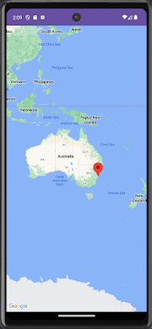](https://blogger.googleusercontent.com/img/a/AVvXsEjOQQIoR2JGQhPQEHoSpvHht424W8ZmEXLio_3RzefA6UZtiYCuiEuDvGDBAUrsmFkL2BPU9XQA0slaiwgW8EcIcXkZvXTExHuNVXOsLC8lRkRMuEn16ojsL8YR3DQtjjPWcAKq3433JZsf5opQ2PZxZVnGHCwjdL1PGe_tGiN3w0-_meI0PUgpknFQasw3)